Genetics and Evolution Terminology
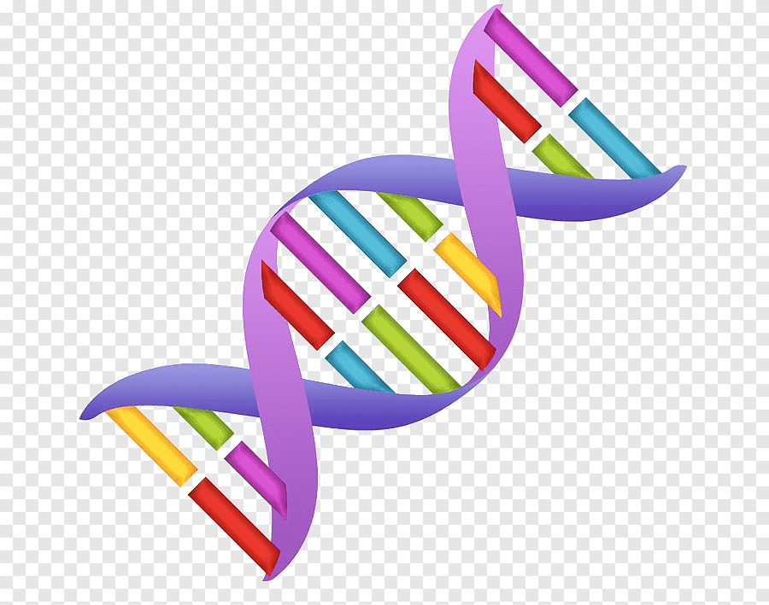

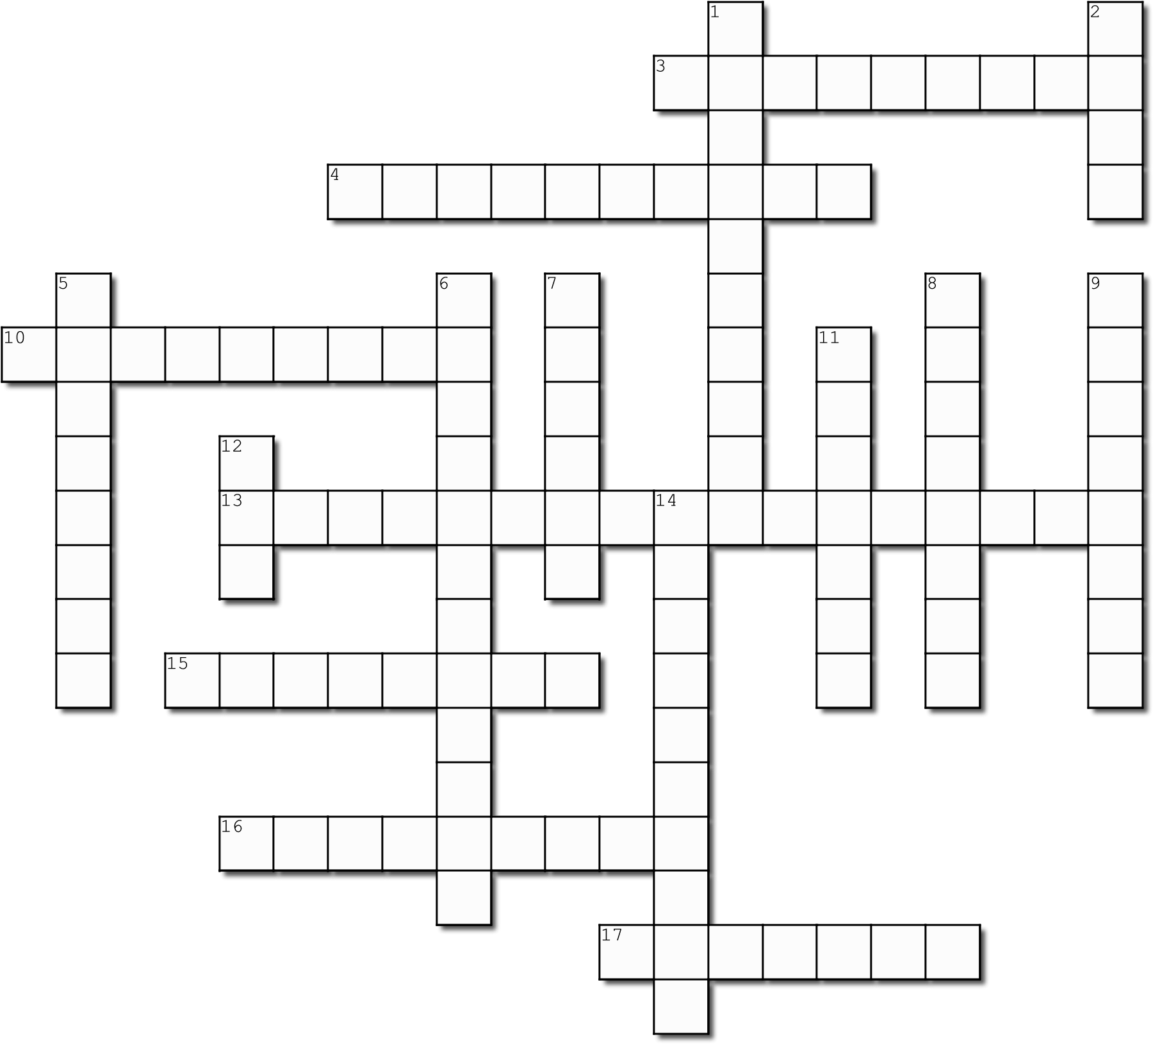

Across
- The description of what the genotype means, eg:
black hair, tongue roller
- Having both the same type of allele for a trait, ie: either both dominant, or both recessive
10. The characteristic that is masked by a dominant allele
13. The process in which organisms that are best adapted to an environment survive and reproduce more than others
15. The letters that show what alleles an organism has, eg: BB or Bb or bb
16. The gradual development of different species from a common ancestor
17. Cell division in sex cells

Down
1. Long, thread-like structures found in the nucleus, made up of genes
- A portion of a chromosome that codes for a particular characteristic or trait
- ‘Family Tree’ which shows genetic information about how characteristics have been passed on through generations
- Having two different alleles - one dominant and one recessive allele for a trait (‘mixed’)
- A version of a gene
- A change or abnormality in a gene or chromosome
9. The gene which determines the outcome, represented by a capital letter, it is always expressed in the phenotype
11. Sex cells (sperm and eggs)
12. Molecule that carries the genetic code or blueprint for making the organism
14. When the gene is carried on the X chromosome

GENETICS AND EVOLUTION REVISION

- The following questions are about DNA:
- What is its function?
- What is its shape called?
- Where is it found?
- What is it made up of?

- Write down the partner DNA strand for this one:
CTAAGCACCGTCGACTTACGTA

- What is a chromosome? How many do humans usually have in their cells?

- The following questions are about sex cells:
- What is another name for sex cells?
- What are the sex cells called in males and in females?
- How many chromosomes do sex cells have? Explain why.

- Explain how males are responsible for determining the sex of the offspring.

- Draw a punnet square for a cross between a plant with red flowers (Rr) and a plant with white flowers (rr)

- In anemones, the gene for having stinging tentacles is dominant over non-stinging tentacles. Work out the predicted genotypes and phenotypes of the offspring produced if a homozygous non-stinging anemone is crossed with a heterozygous stinging anemone.

- Long hair in dogs is dominant over short hair. Work out the genotypes and phenotypes of the offspring produced by a homozygous long haired dog and a short haired dog.

- Large wing span is dominant over short wing span in owls. Calculate the percentage of offspring that would be expected to have a large wing span as a result of a cross between two heterozygous wing span owls.

- A brown mouse is crossed with a white mouse. All of the offspring are brown. What does this suggest about the gene for brown colouring?

- Being colour blind in humans is a sex-linked recessive trait. What are the possible genotypes and phenotypes for the offspring of a colour blind male and a carrier female?

- The gene for Schmuck’s disease is recessive and carried on the X chromosome. If a mother who has the disease has children with a father that doesn’t have the disease, what possible genotypes and phenotypes are there for their children?

- Explain what a mutation is. List the different causes of mutations and the differences and consequences of a germline mutation versus a somatic mutation.

- The pedigree chart below shows how Cystic Fibrosis, an autosomal recessive disease, can be traced through three generations.

- Write the genotypes of the individuals on the lines next to each one.

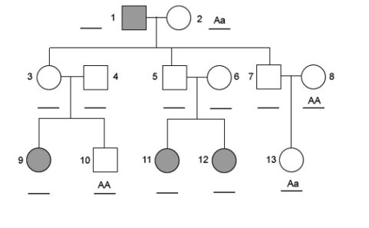
- What is the phenotype and sex of
- Individual 3
- Individual 5
- Individual 12

- How many grandsons does individual 2 have?

- The following questions are about Evolution:
- Define Evolution
- Explain the process of Natural Selection
- Outline how each of the following provide evidence for the theory of evolution:
- Fossil record
- Comparative anatomy
- Embryology
- DNA

